I. Install WordPress for PCP

1. Download WordPress from <https://wordpress.org/>
2. On your local machine, create a folder called **primarycareplus.com** in your htdocs or wwwroot folder.
   1. For XAMP: C:\xampp\htdocs\primarycareplus.com
3. Copy the contents of the downloaded WordPress zip folder into the **primarycareplus.com** directory you just created.

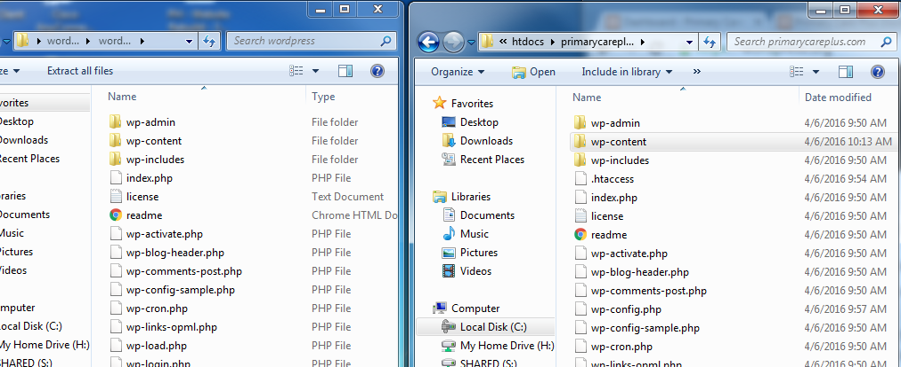

II. Set up PCP Database

1. Open the wp-config.php file from your local back-up of the live PCP site. I used the backup file from Vault Press. The wp-config.php file will be in the root directory of the backup file.
2. Using your phpMyAdmin panel, create a new MySQL database with same name specified in the wp-config.php file. The line of code with the DB name will look like this: **define('DB_NAME', 'primarycare_wp');**
3. Using your phpMyAdmin panel, create a new user with global admin privileges. The username and password will be the same that the one specified in the wp-config.php file.
4. Copy the wp-config.php file into the root of your new WordPress install.
   1. Make sure the DB_HOST line of code looks like this: **define('DB_HOST', 'localhost:3306');**
5. In your browser, go to: <http://localhost/primarycareplus.com/> and complete the installation of Word Press.

III. Migrate the data

1. Install DB Migrate Pro on your local word press.
2. Get the DB Migrate Pro URL and access code from the live PCP web site.
3. On your local WP, go to the DB Migrate Pro Plugin.
   1. Select the **Migrate** tab
   2. Select **Pull** for datapull.
   3. Enter URL and security code when prompted.
   4. Execute the data pull.

IV. Copy back-up files from live back-up to local WP install

1. Copy the directories below into the same folder location as they are in the back-up folder structure
   1. Copy the **Canvas** and **Clean Canvas** folders from the themes directory.
   2. Copy the **Uploads** folder
   3. Copy the **Plugins** folder

V. Change local WP settings

1. Go to: <http://localhost/primarycareplus.com/wp-admin>

2. Go to: Settings – General Settings

3. Change any **https** to **http**.

Test the site and see if it works.